**Tables:**

Convert it to Hive tables.

Create table dept(

  deptno number(2,0),

  dname  varchar2(14),

  loc    varchar2(13)

);

Create table dept(deptno int,deptname string,deptloc string) row format delimited fields terminated by ‘,’;

Create table emp(

  empno    number(4,0),

  ename    varchar2(10),

  job      varchar2(9),

  mgr      number(4,0),

  hiredate date,

  sal      number(7,2),

  comm     number(7,2),

  deptno   number(2,0)

);

Create table emp(empno int,ename string,job string,mgr int,hiredate timestamp,sal float,comm int,deptno int) row format delimited fields terminated by ‘,’;

create table bonus(

  ename varchar2(10),

  job   varchar2(9),

  sal   number,

  comm  number

);

Create table bonus(ename string,job string,sal float,comm int) row format delimited fields by ‘,’;

create table salgrade(

  grade number,

  losal number,

  hisal number

);

Create table salgrade(grade int,losal float,hisal float) row format delimited fields terminated by ‘,’;

**Don’t Insert the value like this.Instead collect this data into the files and load the files using LOAD command**

Insert into dept values(10, 'ACCOUNTING', 'NEW YORK');

Insert into dept values(20, 'RESEARCH', 'DALLAS');

Insert into dept values(30, 'SALES', 'CHICAGO');

Insert into dept values(40, 'OPERATIONS', 'BOSTON');

load data local inpath '/home/hduser/assignment/dept.txt' overwrite into table dept;

Insert into emp values(7839, 'KING', 'PRESIDENT', null,to_date('17-11-1981','dd-mm-yyyy'),5000, null, 10);

Insert into emp values(7698, 'BLAKE', 'MANAGER', 7839,to_date('1-5-1981','dd-mm-yyyy'),2850, null, 30);

Insert into emp values(7782, 'CLARK', 'MANAGER', 7839,to_date('9-6-1981','dd-mm-yyyy'), 2450, null, 10);

Insert into emp values(7566, 'JONES', 'MANAGER', 7839,to_date('2-4-1981','dd-mm-yyyy'), 2975, null, 20);

Insert into emp values(7788, 'SCOTT', 'ANALYST', 7566, to_date('13-JUL-87','dd-mm-rr') - 85,3000, null, 20);

Insert into emp values(7902, 'FORD', 'ANALYST', 7566,to_date('3-12-1981','dd-mm-yyyy'), 3000, null, 20);

Insert into emp values(7369, 'SMITH', 'CLERK', 7902,to_date('17-12-1980','dd-mm-yyyy'),800, null, 20);

Insert into emp values(7499,'ALLEN','SALESMAN',7698,to_date('20-2-1981', 'dd-mm-yyyy'), 1600, 300, 30);

Insert into emp values(7521, 'WARD', 'SALESMAN', 7698,to_date('22-2-1981','dd-mm-yyyy'),1250, 500, 30);

Insert into emp values(7654, 'MARTIN', 'SALESMAN', 7698,to_date('28-9-1981','dd-mm-yyyy'),1250, 1400, 30);

Insert into emp values(7844, 'TURNER', 'SALESMAN', 7698, to_date('8-9-1981','dd-mm-yyyy'), 1500, 0, 30);

Insert into emp values(7876, 'ADAMS', 'CLERK', 7788,to_date('13-JUL-87', 'dd-mm-rr') - 51, 1100, null, 20);

Insert into emp values(7900, 'JAMES', 'CLERK', 7698,to_date('3-12-1981','dd-mm-yyyy'),950, null, 30);

Insert into emp values(7934, 'MILLER', 'CLERK', 7782,to_date('23-1-1982','dd-mm-yyyy'), 1300, null, 10);

load data local inpath '/home/hduser/assignment/empData.txt' overwrite into table emp;

/*

insert into salgrade values (1, 700, 1200);

insert into salgrade values (2, 1201, 1400);

insert into salgrade values (3, 1401, 2000);

insert into salgrade values (4, 2001, 3000);

insert into salgrade values (5, 3001, 9999);

*/

load data local inpath '/home/hduser/assignment/salgrade.txt' overwrite into table salgrade;

commit;

--assignment

--1) Select all the Information Regarding the Employee Table

select*from empm

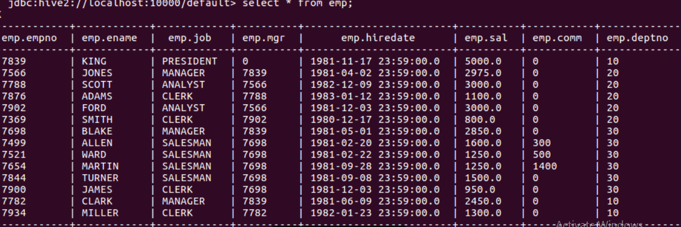

select*from deptm

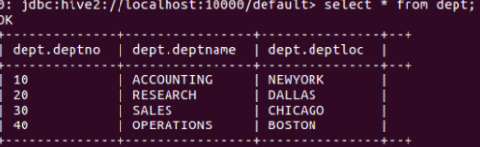

--2) List all the employees who have a sal between 1000 and 2000.

select ename from emp where sal > 1000 and sal < 2000;

OK

+---------+--+

| ename |

+---------+--+

| ADAMS |

| ALLEN |

| WARD |

| MARTIN |

| TURNER |

| MILLER |

+---------+--+

--3) Display all the different job types.

Select distinct(job) from emp;

OK

+------------+--+

| job |

+------------+--+

| ANALYST |

| CLERK |

| MANAGER |

| PRESIDENT |

| SALESMAN |

+------------+--+

--4) List the details of the employees in departments 10 and 20 in alphabetical order.

select * from emp where deptno in(10,20) order by ename;

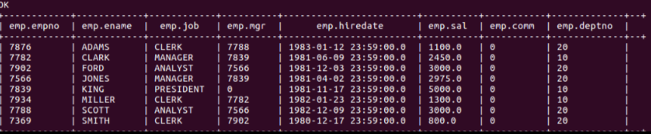

--5) List names and jobs of all clerks in department 20.

select ename,job from emp where job = 'CLERK' and deptno = 20;

OK

+--------+--------+--+

| ename | job |

+--------+--------+--+

| ADAMS | CLERK |

| SMITH | CLERK |

--6) Display all employee names, which have TH and LL in them.

select ename from emp where ename like '%TH%' or ename like '%LL%';

OK

+---------+--+

| ename |

+---------+--+

| SMITH |

| ALLEN |

| MILLER |

+---------+--+

--7) List the following details for all employees who have a manager.

Select * from emp where mgr!=0;

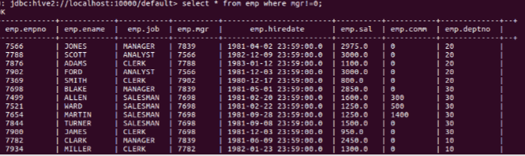

--8) Display name and total remuneration for all employees.

select ename ,sal+comm as totalsalary from emp;

OK

+---------+--------------+--+

| ename | totalsalary |

+---------+--------------+--+

| KING | 5000.0 |

| JONES | 2975.0 |

| SCOTT | 3000.0 |

| ADAMS | 1100.0 |

| FORD | 3000.0 |

| SMITH | 800.0 |

| BLAKE | 2850.0 |

| ALLEN | 1900.0 |

| WARD | 1750.0 |

| MARTIN | 2650.0 |

| TURNER | 1500.0 |

| JAMES | 950.0 |

| CLARK | 2450.0 |

| MILLER | 1300.0 |

+---------+--------------+--+

--9) Display all employees who were hired during 1993.

Select * from emp where hiredate >= ‘1983-01-01 00:00:00.0’ and hiredate <= ‘1983-12-31 23:59:00.0’;

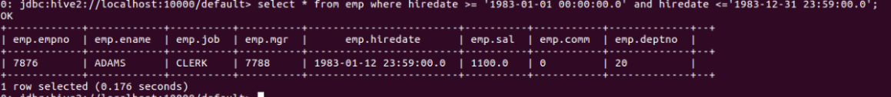

--10) Display name, annual sal and commission of all salespeople whose monthly salary is greater than

-- their commission. The output should be order by salary,

-- highest first. If two employees have the same sal sort by employee names, within the highest salary order.

select ename,sal*12 as annualsalary,comm from emp where sal > comm order by annualsalary desc,ename asc;

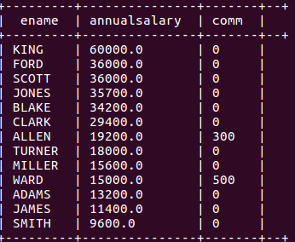

--11)List the employees name and salary incremented by 15% and express as whole number of Rupees.

select ename,cast(round(sal+sal*0.15) as int) as incremented_sal from emp;

+---------+------------------+--+

| ename | incremented_sal |

+---------+------------------+--+

| KING | 5750 |

| JONES | 3421 |

| SCOTT | 3450 |

| ADAMS | 1265 |

| FORD | 3450 |

| SMITH | 920 |

| BLAKE | 3278 |

| ALLEN | 1840 |

| WARD | 1438 |

| MARTIN | 1438 |

| TURNER | 1725 |

| JAMES | 1093 |

| CLARK | 2818 |

| MILLER | 1495 |

+---------+------------------+--+

--12) Display each employees name and hiredate from dept 20. Make sure that you specify the alias ‘Date Hired’ after your expression otherwise the formatted column will wrap;it uses a width of 80 characters which is the default for character columns.

select ename,hiredate as DateHired from emp where deptno=20;

+--------+------------------------+--+

| ename | datehired |

+--------+------------------------+--+

| JONES | 1981-04-02 23:59:00.0 |

| SCOTT | 1982-12-09 23:59:00.0 |

| ADAMS | 1983-01-12 23:59:00.0 |

| FORD | 1981-12-03 23:59:00.0 |

| SMITH | 1980-12-17 23:59:00.0 |

--13) Display each employee name with hiredate, and salary review data. Assume review date

--is one year after hire date. Order the Output in Ascending.

select ename,hiredate as datehired,date_add(hiredate,365) as reviewdate from emp;

OK

+---------+------------------------+-------------+--+

| ename | datehired | reviewdate |

+---------+------------------------+-------------+--+

| KING | 1981-11-17 23:59:00.0 | 1982-11-17 |

| JONES | 1981-04-02 23:59:00.0 | 1982-04-02 |

| SCOTT | 1982-12-09 23:59:00.0 | 1983-12-09 |

| ADAMS | 1983-01-12 23:59:00.0 | 1984-01-12 |

| FORD | 1981-12-03 23:59:00.0 | 1982-12-03 |

| SMITH | 1980-12-17 23:59:00.0 | 1981-12-17 |

| BLAKE | 1981-05-01 23:59:00.0 | 1982-05-01 |

| ALLEN | 1981-02-20 23:59:00.0 | 1982-02-20 |

| WARD | 1981-02-22 23:59:00.0 | 1982-02-22 |

| MARTIN | 1981-09-28 23:59:00.0 | 1982-09-28 |

| TURNER | 1981-09-08 23:59:00.0 | 1982-09-08 |

| JAMES | 1981-12-03 23:59:00.0 | 1982-12-03 |

| CLARK | 1981-06-09 23:59:00.0 | 1982-06-09 |

| MILLER | 1982-01-23 23:59:00.0 | 1983-01-23 |

+---------+------------------------+-------------+--+

--14) Print a list of employees displaying ‘just salary if more than 1500’.

--If exactly 1500 display ‘On Target’, if less than 1500 display

--‘Below Target’

select ename,sal,case when sal > 1500 then 'Just Salary' when sal == 1500 then 'To Target' when sal<1500 then 'Below Target' end as status from emp;

OK

+---------+---------+---------------+--+

| ename | sal | status |

+---------+---------+---------------+--+

| KING | 5000.0 | Just Salary |

| JONES | 2975.0 | Just Salary |

| SCOTT | 3000.0 | Just Salary |

| ADAMS | 1100.0 | Below Target |

| FORD | 3000.0 | Just Salary |

| SMITH | 800.0 | Below Target |

| BLAKE | 2850.0 | Just Salary |

| ALLEN | 1600.0 | Just Salary |

| WARD | 1250.0 | Below Target |

| MARTIN | 1250.0 | Below Target |

| TURNER | 1500.0 | To Target |

| JAMES | 950.0 | Below Target |

| CLARK | 2450.0 | Just Salary |

| MILLER | 1300.0 | Below Target |

+---------+---------+---------------+--+

--15)Write a query that will return the Day of the week (i.e. Monday) for any date entered in the format DD: MM.YY.

select date_format(hiredate,'u') from emp;

--16) Write a query to calculate the length of time any employee has been with the company.

select ename,round(round(months_between(current_date,hiredate))/12) from emp;

--17) Find the minimum sal of the Employees.

Select min(sal) as lowsalary from emp;

+------------+--+

| lowsalary |

+------------+--+

| 800.0 |

+------------+--+

--18) Find the minimum, maximum and avg sal of all employees.

select min(sal) as lowsalary,max(sal) as highsalary,avg(sal) as AverageSalary from emp;

+------------+-------------+--------------------+--+

| lowsalary | highsalary | averagesalary |

+------------+-------------+--------------------+--+

| 800.0 | 5000.0 | 2073.214285714286 |

+------------+-------------+--------------------+--+

--19) List the minimum and maximum sal for each job type.

select job,min(sal) as lowsalary,max(sal) as highsalary from emp group by job;

+------------+------------+-------------+--+

| job | lowsalary | highsalary |

+------------+------------+-------------+--+

| ANALYST | 3000.0 | 3000.0 |

| CLERK | 800.0 | 1300.0 |

| MANAGER | 2450.0 | 2975.0 |

| PRESIDENT | 5000.0 | 5000.0 |

| SALESMAN | 1250.0 | 1600.0 |

+------------+------------+-------------+--+

--20) Find out how many managers there are without listing them.

select count(distinct(mgr)) as mgr_count from emp;

+------------+--+

| mgr_count |

+------------+--+

| 7 |

+------------+--+

--21) Find the avg sal and avg total remuneration for each job type.

select job,round(avg(sal)) as Averagesalary,round(avg(sal+comm)) as Average_Renum from emp group by job;

+------------+----------------+----------------+--+

| job | averagesalary | average_renum |

+------------+----------------+----------------+--+

| ANALYST | 3000.0 | 3000.0 |

| CLERK | 1038.0 | 1038.0 |

| MANAGER | 2758.0 | 2758.0 |

| PRESIDENT | 5000.0 | 5000.0 |

| SALESMAN | 1400.0 | 1950.0 |

+------------+----------------+----------------+--+

--22) Find out the diff between highest and lowest sal.

select max(sal)-min(sal) as difference from emp;

+-------------+--+

| difference |

+-------------+--+

| 4200.0 |

+-------------+--

--23) Find all dept, which have more than 3 employees.

select deptno,count(empno) as count_of_employees from emp group by deptno having count_of_employees > 3;

+---------+---------------------+--+

| deptno | count_of_employees |

+---------+---------------------+--+

| 20 | 5 |

| 30 | 6 |

+---------+---------------------+--+

--24) Check whether all employee numbers are indeed unique.

select empno from emp group by empno having count(empno) = 1;

--25) List lowest paid employees working for each manager, exclude any group

--Where the minimum sal is less than 1000. Sort the output by sal.

select empno,ename,mgr,sal from emp where sal in(select min(sal) from emp group by mgr) and sal > 1000 order by sal;

+--------+---------+-------+---------+--+

| empno | ename | mgr | sal |

+--------+---------+-------+---------+--+

| 7876 | ADAMS | 7788 | 1100.0 |

| 7934 | MILLER | 7782 | 1300.0 |

| 7782 | CLARK | 7839 | 2450.0 |

| 7902 | FORD | 7566 | 3000.0 |

| 7788 | SCOTT | 7566 | 3000.0 |

| 7839 | KING | 0 | 5000.0 |

+--------+---------+-------+---------+--+

--26) Display all EMP names and their dept names in dept name order.

select ename,deptname from emp e join dept d on e.deptno=d.deptno order by deptname;

+---------+-------------+--+

| ename | deptname |

+---------+-------------+--+

| KING | ACCOUNTING |

| CLARK | ACCOUNTING |

| MILLER | ACCOUNTING |

| SMITH | RESEARCH |

| FORD | RESEARCH |

| ADAMS | RESEARCH |

| SCOTT | RESEARCH |

| JONES | RESEARCH |

| TURNER | SALES |

| MARTIN | SALES |

| WARD | SALES |

| ALLEN | SALES |

| BLAKE | SALES |

| JAMES | SALES |

+---------+-------------+--+

--27) Display all EMP names, dept number and name.

select e.ename as EmployeeName,d.deptno as DeptId,d.deptname as DeptName from emp e join dept d on e.deptno=d.deptno;

+---------------+---------+-------------+--+

| employeename | deptid | deptname |

+---------------+---------+-------------+--+

| KING | 10 | ACCOUNTING |

| JONES | 20 | RESEARCH |

| SCOTT | 20 | RESEARCH |

| ADAMS | 20 | RESEARCH |

| FORD | 20 | RESEARCH |

| SMITH | 20 | RESEARCH |

| BLAKE | 30 | SALES |

| ALLEN | 30 | SALES |

| WARD | 30 | SALES |

| MARTIN | 30 | SALES |

| TURNER | 30 | SALES |

| JAMES | 30 | SALES |

| CLARK | 10 | ACCOUNTING |

| MILLER | 10 | ACCOUNTING |

+---------------+---------+-------------+--+

--28) Display the name, location and dept of employees whose sal is more than 1500 a month.

select e.ename as EmployeeName,d.deptno as DeptId,d.deptloc as DeptLoc from emp e join dept d on e.deptno=d.deptno where e.sal > 1500;

+---------------+---------+----------+--+

| employeename | deptid | deptloc |

+---------------+---------+----------+--+

| KING | 10 | NEWYORK |

| JONES | 20 | DALLAS |

| SCOTT | 20 | DALLAS |

| FORD | 20 | DALLAS |

| BLAKE | 30 | CHICAGO |

| ALLEN | 30 | CHICAGO |

| CLARK | 10 | NEWYORK |

+---------------+---------+----------+--+

--29) Produce a list showing employees’ sal grades.

select empno,ename,sal,dense_rank() over (order by sal desc) as SalGrade from emp;

+--------+---------+---------+-----------+--+

| empno | ename | sal | salgrade |

+--------+---------+---------+-----------+--+

| 7839 | KING | 5000.0 | 1 |

| 7788 | SCOTT | 3000.0 | 2 |

| 7902 | FORD | 3000.0 | 2 |

| 7566 | JONES | 2975.0 | 3 |

| 7698 | BLAKE | 2850.0 | 4 |

| 7782 | CLARK | 2450.0 | 5 |

| 7499 | ALLEN | 1600.0 | 6 |

| 7844 | TURNER | 1500.0 | 7 |

| 7934 | MILLER | 1300.0 | 8 |

| 7521 | WARD | 1250.0 | 9 |

| 7654 | MARTIN | 1250.0 | 9 |

| 7876 | ADAMS | 1100.0 | 10 |

| 7900 | JAMES | 950.0 | 11 |

| 7369 | SMITH | 800.0 | 12 |

+--------+---------+---------+-----------+--+

--30) Show only employees on Grade 3.

select * from (select empno,ename,sal,dense_rank() over (order by sal desc) as SalGrade from emp)e where SalGrade =3;

+----------+----------+---------+-------------+--+

| e.empno | e.ename | e.sal | e.salgrade |

+----------+----------+---------+-------------+--+

| 7566 | JONES | 2975.0 | 3 |

+----------+----------+---------+-------------+--+

--31) Show all employees in Dallas.

select e.empno,e.ename,d.deptloc from emp e join dept d on d.deptno=e.deptno where d.deptloc ='DALLAS';

+----------+----------+------------+--+

| e.empno | e.ename | d.deptloc |

+----------+----------+------------+--+

| 7566 | JONES | DALLAS |

| 7788 | SCOTT | DALLAS |

| 7876 | ADAMS | DALLAS |

| 7902 | FORD | DALLAS |

| 7369 | SMITH | DALLAS |

+----------+----------+------------+--+

--32) List the Employee Name, job, sal, grade and dept name for everyone in the company except clerks.

-- Sort on salary, displaying the highest sal first.

--except select e.ename,e.job,e.sal,g.grade,d.dname

-- from empm e,deptm d,salgradem g

-- where e.job='clerk'

select e.ename as employee_name,e.job as Designation,e.sal as Salary,dense_rank() over(order by e.sal desc) as Grade,d.deptname as Department from emp e join dept d on d.deptno=e.deptno where e.job !='CLERK' order by salary desc;

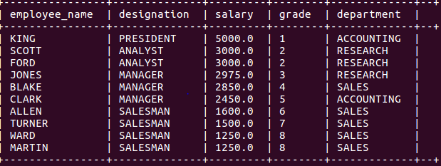

--33) List the following details of EMP whose earn 36000 a year or who are clerks.

select * from emp where job ='CLERK' or (sal+comm)*12 > 36000;

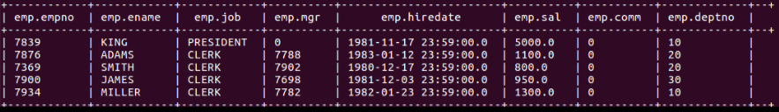

--34) Display the dept that has no employees.

select d.deptno from dept d left outer join emp e on d.deptno = e.deptno group by d.deptno having count(e.empno) =0;

+-----------+--+

| d.deptno |

+-----------+--+

| 40 |

+-----------+--+

--35) List all EMP by name and number along with their manager’s name and number.

select e1.empno,e1.ename,e2.ename,e2.job from emp e1 join emp e2 where e1.mgr=e2.empno and e1.empno!=e2.empno;

+-----------+-----------+-----------+------------+--+

| e1.empno | e1.ename | e2.ename | e2.job |

+-----------+-----------+-----------+------------+--+

| 7566 | JONES | KING | PRESIDENT |

| 7698 | BLAKE | KING | PRESIDENT |

| 7782 | CLARK | KING | PRESIDENT |

| 7788 | SCOTT | JONES | MANAGER |

| 7902 | FORD | JONES | MANAGER |

| 7876 | ADAMS | SCOTT | ANALYST |

| 7369 | SMITH | FORD | ANALYST |

| 7499 | ALLEN | BLAKE | MANAGER |

| 7521 | WARD | BLAKE | MANAGER |

| 7654 | MARTIN | BLAKE | MANAGER |

| 7844 | TURNER | BLAKE | MANAGER |

| 7900 | JAMES | BLAKE | MANAGER |

| 7934 | MILLER | CLARK | MANAGER |

+-----------+-----------+-----------+------------+--+

--36) Modify solution to above question to display KING who has no manager.

select empno,ename from emp where mgr=0;

+--------+--------+--+

| empno | ename |

+--------+--------+--+

| 7839 | KING |

+--------+--------+--+

--37) Find the job that was filled in the first half of 1983, and the

--same job that was filled during the same period in 1984.

select e1.job from emp e1 join (select job from emp where hiredate >= '1981-01-01 00:00:00.0' and hiredate <= '1981-06-30 23:59:59.0'group by job) e2 where e1.job=e2.job and e1.hiredate >= '1982-01-01 00:00:00.0' and e1.hiredate <= '1982-06-30 23:59:59.0';

--38) Find all employees who joined the company before their manager.

select e1.empno as EmployeeId,e1.ename as EmployeeName,e1.hiredate as EmployeeHiredate,e2.empno as ManagerId,e2.ename as ManagerName,e2.hiredate as ManagerHiredate from emp e1 join emp e2 where e1.mgr=e2.empno and e1.hiredate < e2.hiredate;

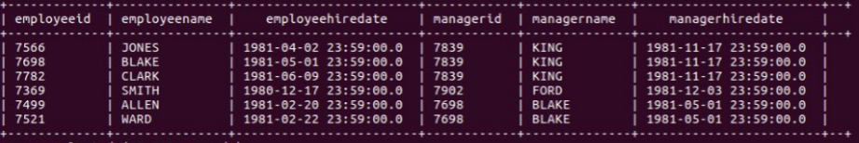

--39) Find another query method for about question.

--40) Find the Employees who earn the highest sal in each job type Sort in Desc Sal order.

select max(sal) as max_salary from emp group by job order by sal desc;

+------------+-------------+--+

| job | max_salary |

+------------+-------------+--+

| PRESIDENT | 5000.0 |

| ANALYST | 3000.0 |

| MANAGER | 2975.0 |

| SALESMAN | 1600.0 |

| CLERK | 1300.0 |

+------------+-------------+--+

--41) Find the Employees who earn the minimum sal for their job. Display the result in ascending order of salary.

create table emp_min_sal_job as select job,min(sal) as min_salary from emp group by job;

select e1.ename as Employee_name,e2.job as Job,e2.min_salary as salary from emp e1 join emp_min_sal_job e2 where e1.job=e2.job and e1.sal = e2.min_salary;

+----------------+------------+---------+--+

| employee_name | job | salary |

+----------------+------------+---------+--+

| KING | PRESIDENT | 5000.0 |

| SCOTT | ANALYST | 3000.0 |

| FORD | ANALYST | 3000.0 |

| SMITH | CLERK | 800.0 |

| WARD | SALESMAN | 1250.0 |

| MARTIN | SALESMAN | 1250.0 |

| CLARK | MANAGER | 2450.0 |

+----------------+------------+---------+--+

--42) Find the most recently hired employees in each dept. Order by hiredates.

select empno,ename from emp where hiredate in(select min(hiredate) from emp group by deptno);

+--------+--------+--+

| empno | ename |

+--------+--------+--+

| 7369 | SMITH |

| 7499 | ALLEN |

| 7782 | CLARK |

+--------+--------+--+

--43) Show the following details for any EMP who earns a sal greater than the avg for their

--dept. sort in deptno order.

select empno,ename,e.deptno from emp e join (select deptno,avg(sal) as average_sal from emp group by deptno) d where e.deptno = d.deptno and e.sal > d.average_sal order by e.deptno;

--44) List all the dept where there are no employees using subquery only.

select deptno from dept where deptno not in(select distinct(deptno) from emp);

+---------+--+

| deptno |

+---------+--+

| 40 |

+---------+--+

--45) Display the following information for the dept with the HIGHEST annual remuneration bill.

select ename,deptno from emp where (sal+comm)*12 in (select max((sal+comm)*12) as renumeration from emp group by deptno);

+--------+---------+--+

| ename | deptno |

+--------+---------+--+

| KING | 10 |

| SCOTT | 20 |

| FORD | 20 |

| BLAKE | 30 |

+--------+---------+--+

--46) Who are the Top 3 Earners of the Company?

select empno,ename,sum(sal+comm)*12 as renumeration from emp group by empno,ename order by renumeration desc limit 3;

+--------+--------+---------------+--+

| empno | ename | renumeration |

+--------+--------+---------------+--+

| 7839 | KING | 60000.0 |

| 7902 | FORD | 36000.0 |

| 7788 | SCOTT | 36000.0 |

+--------+--------+---------------+--+

--47) In which year did most People join the Company? Display the year and Number of employees.

create table max_emp_hire_year as select year(hiredate) as Year,count(ename) as NoofEmployees from emp group by year(hiredate);

select year,noofemployees from max_emp_hire_year where noofemployees in(select max(noofemployees) from max_emp_hire_year);

+-------+----------------+--+

| year | noofemployees |

+-------+----------------+--+

| 1981 | 10 |

+-------+----------------+--+

--48) Modify above question to also display the avg sal figure for the dept.

--49) Write a Query to display an ‘*’ against the row of the most recently hired employee.

--Display ENAME, HIREDATE and column.

SELECTCONVERT(VARCHAR(10),ENAME)+'*'AS "MODIFIED NAME" ,HIREDATE FROM EMPm WHEREDATEDIFF(DD,HIREDATE,GETDATE())<=(SELECTMIN(DATEDIFF(DD,HIREDATE,GETDATE()))FROM EMPm )

--50) Replace Salesman with Salesperson in the Employee Table.

--51) Display the Number of Months between getdate( ) and Hiredate of the EMP Table.

select empno,ename,round(months_between(current_date,hiredate)) from emp;

+--------+---------+--------+--+

| empno | ename | c2 |

+--------+---------+--------+--+

| 7839 | KING | 425.0 |

| 7566 | JONES | 433.0 |

| 7788 | SCOTT | 413.0 |

| 7876 | ADAMS | 411.0 |

| 7902 | FORD | 425.0 |

| 7369 | SMITH | 436.0 |

| 7698 | BLAKE | 432.0 |

| 7499 | ALLEN | 434.0 |

| 7521 | WARD | 434.0 |

| 7654 | MARTIN | 427.0 |

| 7844 | TURNER | 428.0 |

| 7900 | JAMES | 425.0 |

| 7782 | CLARK | 431.0 |

| 7934 | MILLER | 423.0 |

+--------+---------+--------+--+

--52) Add 2 Months for the existing Sysdate and Display the Result of the Employee Table

--and also display the Next Day of the Hiredate.

select ename,add_months(current_date,2) as sys_date,date_add(hiredate,1) as hiredate from emp;

+---------+-------------+-------------+--+

| ename | sys_date | hiredate |

+---------+-------------+-------------+--+

| KING | 2017-06-27 | 1981-11-18 |

| JONES | 2017-06-27 | 1981-04-03 |

| SCOTT | 2017-06-27 | 1982-12-10 |

| ADAMS | 2017-06-27 | 1983-01-13 |

| FORD | 2017-06-27 | 1981-12-04 |

| SMITH | 2017-06-27 | 1980-12-18 |

| BLAKE | 2017-06-27 | 1981-05-02 |

| ALLEN | 2017-06-27 | 1981-02-21 |

| WARD | 2017-06-27 | 1981-02-23 |

| MARTIN | 2017-06-27 | 1981-09-29 |

| TURNER | 2017-06-27 | 1981-09-09 |

| JAMES | 2017-06-27 | 1981-12-04 |

| CLARK | 2017-06-27 | 1981-06-10 |

| MILLER | 2017-06-27 | 1982-01-24 |

+---------+-------------+-------------+--+

--53) Display the Last day of the given format dd-mm-yyyy.

select last_day(hiredate) from emp;

--54) Display all the Employees who earn less than their managers.

select e1.empno,e1.ename from emp e1 join emp e2 where e1.mgr=e2.empno and e1.sal < e2.sal;

+-----------+-----------+--+

| e1.empno | e1.ename |

+-----------+-----------+--+

| 7566 | JONES |

| 7698 | BLAKE |

| 7782 | CLARK |

| 7876 | ADAMS |

| 7369 | SMITH |

| 7499 | ALLEN |

| 7521 | WARD |

| 7654 | MARTIN |

| 7844 | TURNER |

| 7900 | JAMES |

| 7934 | MILLER |

--55) Display the Lowest Sal of Each Department using subquery.

select deptno,sal from emp where sal in(select min(sal) from emp group by deptno);

+---------+---------+--+

| deptno | sal |

+---------+---------+--+

| 20 | 800.0 |

| 30 | 950.0 |

| 10 | 1300.0 |

+---------+---------+--+

--56) Display the Employees who earn more than the lowest sal in Dept 30

select * from emp e join (select min(sal) as minsal from emp where deptno =30) d where e.sal > d.minsal;

--57) Display the Employees who earn more than every employee in the Department 30.

select * from emp e join (select max(sal) as maxsal from emp where deptno =30) d where e.sal > d.maxsal;

--58) Display the name, job and hiredate for employees whose sal is greater than the

-- highest sal in any sales department.

select empno,ename,job,hiredate from emp e join (select max(sal) as salary from emp where deptno in(select deptno from dept where deptname ='SALES'))d where e.sal > d.salary;

--59) Display all the Employees whose department is not in Department table.

select empno,ename,job from emp where deptno not in(select deptno from dept);